

**UNIVERSITI TUNKU ABDUL RAHMAN**

**Faculty of Science**

**Bachelor of Science (HONS) Statistical Computing**

**and Operations Research**

**UDPS2163 Inventory Control and Decision Analysis**

|  |  |  |
| --- | --- | --- |
| **Name** | **ID** | **Year / Trimester** |
| Ngu Yi Hui | 1801438 | Y2S1 |
| Lim Chien Ai | 1704072 | Y2S1 |

Lecturer: Mr. Liew Kah Fai

**1.0 Introduction**

A university library should provide services and quality resources in support of the advancement of learning, research and so on for students. In order to meet the users’ needs, the quality of library services should be evaluated.

In this paper, we are going to study the quality of service of UTAR Library in Kampar campus. We measure the users' perception of library services quality in three criteria: “Affect of Service”, “Information Control”, and “Library as Place”. This is a questionnaire-based survey. The questionnaire consists of three main criteria which are mentioned above. The “Affect of Service” consists of 5 sub-criteria, 7 sub-criteria are fallen under the “Information Control” and 5 sub-criteria are categorized in the “Library as Place”. First of all, we surveyed 15 UTAR students who went to UTAR Library for at least one time. Then, we analyzed the criteria with sub-criteria by using the Analytical Hierarchy Process (AHP) which is a tool that can be used to determine the main factors for the quality of service of UTAR Library.

**2.0 Problem statement**

Quality of services is an important aspect for the library to satisfy students in their learning process. The library must provide a sufficient collection of information and good quality of services for students to generate a conducive learning environment. However, we often hear some complaints on library service quality in UTAR Kampar campus.

Thus, we are interested to know which criteria of the service quality of the library that UTAR students are mostly focused on in this paper. We assessed the library service quality in three main criteria with relative sub-criteria by distributing the survey form. After collecting the data, we analyzed them to evaluate the most important factors for the service quality of the library by using AHP.

**3.0 Literature Review**

***JOURNAL 1***

 Journal title:

Service quality in University of Colombo libraries: An assessment

Objective:

The objective of this journal is to determine the service quality in term of underlying dimensions of the University of Colombo Library System from the library’s user perspectives and to identify the best predictors in term of overall service quality for the system of the University of Colombo Library.

Data:

In order to determine the service quality factors of University of Colombo library, a survey was conducted. This university had a total student of 12158 and 475 of academic staff in the year of 2008. There is a total of 855 questionnaires printed and distributed to the library users and 634 valid questionnaires were received from the user survey. The questionnaires were distributed from the end of May 2008 until the end of June 2008.

Results:

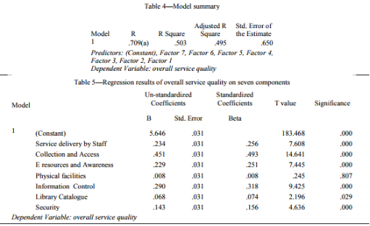

The factor analysis is performed to determine the underlying dimensions of service quality. In this study, seven dimensions were identified via factor analysis that can explain the quality of service from the library user perceptions. These dimensions consist of collection and access, e-resources and awareness, service delivery by staff, physical facilities, information control, library catalog, and security.

Next, the regression analysis is used to determine the best predictors of overall service quality on seven components. From the table above, noticed that there is one non-significant factor (physical facilities), in which the beta value is only 0.008 and the p-value is greater the significance level 0.05. From this information, found out that this factor is not contributing much to this model. The table above shows that the best predictors of overall service quality of university of Colombo library system are collection and access.

***JOURNAL 2***

 Journal title:

Service Quality in Academic Library: University Students’ Perspectives

Objective:

The objective of this journal is to examine the perceptions of university students on the quality of library services at Mzumbe University main campus.

Data:

Data were collected through structured self-administered questionnaires. The study had a total number of 158 respondents who were all business students at undergraduate level studying at the main campus of Mzumbe University, Morogoro, Tanzania. The elements used to examine the library service quality are tangibles, responsiveness, assurance, and reliability. The weighted scores on the perceptions were calculated to know the satisfaction of students on the delivered services.

Results:

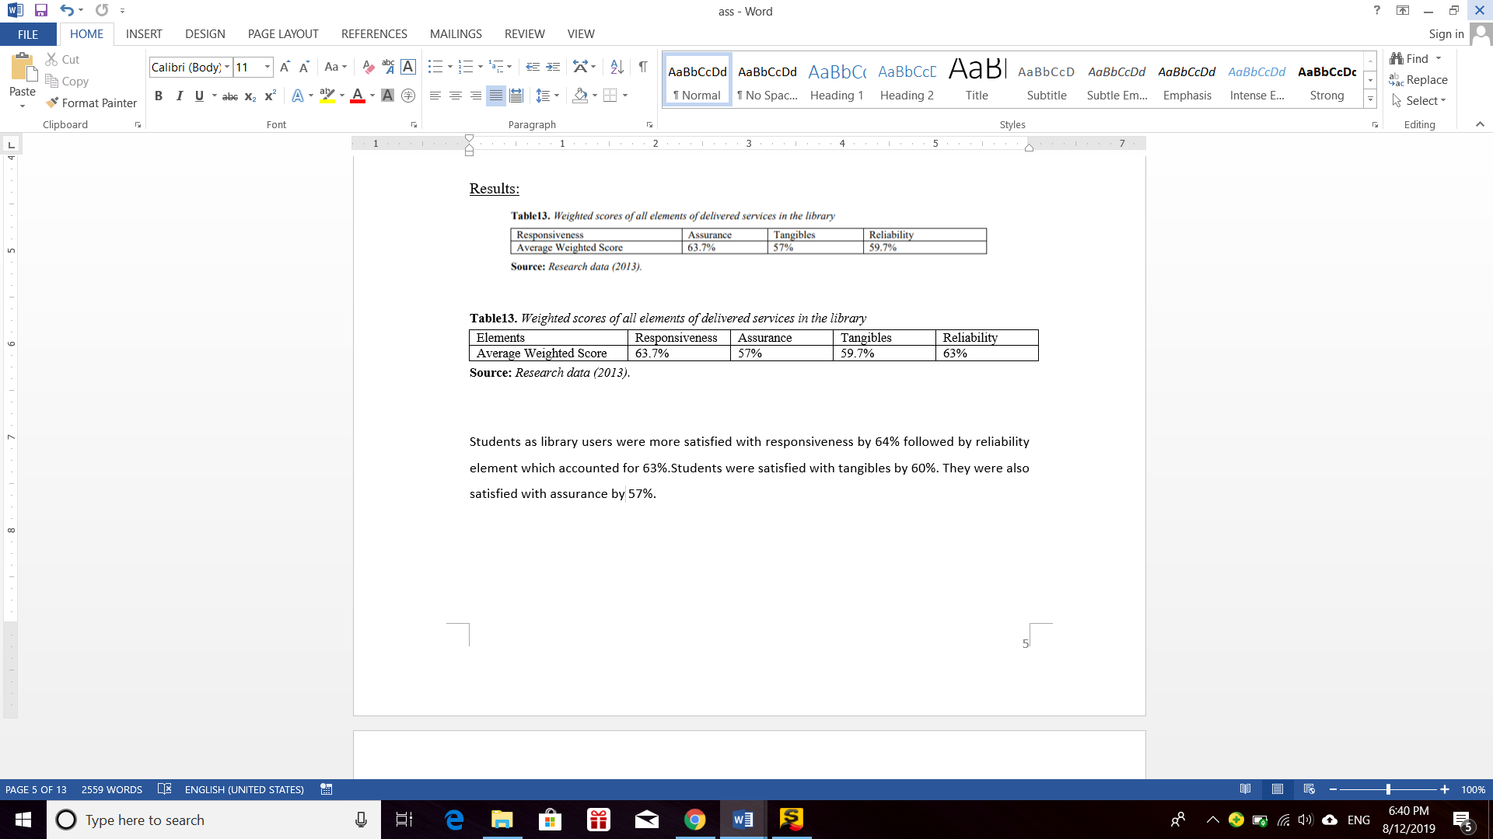

According to Table13, the library users were more satisfied with responsiveness (63.7%) followed by reliability (63%), tangibles (59.7%) and lastly assurance (57%).

In terms of responsiveness, library users were more satisfied with the library cards processing procedures and payments procedures for overdue library collections. Further, staff readiness and willingness to respond to users’ requests were less satisfied by the students.

In terms of reliability, library users were more satisfied with the sufficiency of up to date and sufficient materials in the library. Besides, they were also satisfied with the availability of needed materials but they were less satisfied with the professionalism of service providers.

In terms of tangibles, library users were more satisfied with the arrangement of library collections and the quietness in the library. However, students were less satisfied with the security at locker place and the library space. Lastly, library users were less satisfied in the elements in assurance which are competence, communication, and confidence of library staff.

**4.0 Methodology**

First of all, 15 questionnaires were distributed to UTAR students for library service quality evaluation. The questions in questionnaires are generally about the preference to the criteria and also sub-criteria in the library service quality. The table below shows the factors of the library service quality:

Table-1 Criteria and sub-criteria for evaluating the quality of library services

|  |  |  |
| --- | --- | --- |
| **No.** | **Criteria** | **Sub-Criteria** |
| 1. | Affect of Service (C1) | Willingness to help users (SC1) |
| Attitudes and behavior (SC2) |
| Duration of service time (SC3) |
| Library opening hours (SC4) |
| Guidance from librarians (SC5) |
| 2. | Information Control (C2) | Updated books (SC6) |
| Variety of books (SC7) |
| Computer facilities (SC8) |
| Internet/WIFI facilities (SC9) |
| Catalog search/OPAC (SC10) |
| Newspaper and magazine collection (SC11) |
| Online journal collection (SC12) |
| 3. | Library as Place (C3) | Locker facilities (SC13) |
| Cleanliness and beauty (SC14) |
| Desk and seating availability (SC15) |
| Lighting (SC16) |
| Temperature setting (SC17) |

After the data was collected, the Analytic Hierarchy Process (AHP) is used to find the weight of the library performance measurement.

Below is the summary of the steps of AHP:

1. All the data of 15 questionnaires were key in into Microsoft Excel.
2. The average of each row of the data was calculated to form the pairwise comparison matrix for criteria. (refer to Appendix-1)
3. The sum of the value in each column of the pairwise comparison matrix was calculated. Each of the values was divided by the total value of each column to obtain the normalized matrix.
4. The average of each row of the normalized data was calculated and rank it. The ranking shows the preference of the criteria.
5. By using the same method as step 2 until step 4, develop a pairwise comparison matrix for the sub-criteria in each criterion. ( refer to Appendix-2)
6. The average was calculated and ranked to find out which sub-criterion is most preferable by the respondents for each of the criterion.
7. All the average of pairwise comparison matrix for criteria was arranged by column to form Q matrix.
8. The average of pairwise comparison matrix for decision alternatives is used to form WT matrix.
9. Q and WT were multiplied to get the overall weight vector, FDW. The best decision alternative will be the decision alternative with the highest weight in FDW.
10. Consistency was checked. If the consistency ratio is smaller or equal to 0.10, the AHP result is acceptable. However, if the ratio is greater than 0.10, serious inconsistencies may exist and AHP may not yield meaningful results.

Table-2 Pairwise comparison scale for AHP preferences

|  |  |
| --- | --- |
| **Scale** | **Definition** |
| 1 | Equal Importance |
| 3 | Moderate Importance |
| 5 | Strong Importance |
| 7 | Very Strong Importance |
| 9 | Absolute Importance |
| 2, 4, 6, 8 | Intermediate Values |

**5.0 Result and Discussion**

By using AHP, we can determine the relative weight of the criteria and sub-criteria for the library service quality. The higher the weight of the criterion, the higher its priority.

Figure-1 Hierarchic structure of the AHP and the weight of the criteria and sub-criteria

***Part A: Compare each criterion***

From the result we obtained, the respondents had the highest preference on the criterion “Information Control” (0.5027) followed by the “Affect of Service” (0.2588). While the criterion “Library as Place” has the lowest weight (0.2385).

“Information Control” is the highest influential factor. In most students’ perspective, a university library should provide a large variety of updated books, reference books, and journal and up-to-date literature, else it loses the meaning of existence. The facilities such as computers and the Internet are also important for students as they would need to find other online resources while studying in the library.

The second highest score for criteria is the “Affect of Service”. Students will need help and guidance from librarians when finding and borrowing books. If the librarians are not willing to help them, they will most probably have a bad impression for the library. As a result, they will decrease the times going to the library just to reduce the probability of having this kind of unpleasant experience.

“Library as Place” is the lowest influential factor. The library environment is the least important to students compared with the other two factors. For them, they can just borrow books and study at their hostel. Therefore, the environment such as locker facilities, seat availability, and the cleanliness has the lowest weight.

*Check for consistency:*

|  |  |  |
| --- | --- | --- |
| Consistency Ratio = | 0.0000314 | (<0.10) |

Since the consistency ratio of our data is smaller than 0.01, the AHP result is acceptable.

***Part B: Compare the relative sub-criteria***

1. ***In criterion C1: Affect of Service***

For the “Affect of Service”, library opening hours has the highest weight (0.2879). While the second highest sub-criterion is the attitudes and behavior of the librarians (0.2536), followed by their willingness to help users (0.1948), and the duration of service time (0.1699). Surprisingly, the guidance from librarians (0.0938) has the lowest weight.

The library opening hours received the highest weight. Many students believe that they will be benefited from an extended library opening hour. Respondents suggest the need to implement some [self-service technology](https://princh.com/self-service-library-system-get-more-patrons-to-library/) so that the library can be opened for a longer period.

The second most important sub factor is the librarians’ attitudes and behavior. Respondents hope that the librarians to be more friendly and willing to help them. They wish to have a more pleasant experience in the library because this will affect their study mood.

The guidance from librarians has the lowest weight among the sub-criteria. Most students go to the library with friends at the first time. Thus, they obtained guidance from their friends and seldom need guidance from librarians.

*Check for consistency:*

|  |  |  |
| --- | --- | --- |
| Consistency Ratio = | 0.0129 | (<0.10) |

Since the consistency ratio of our data is smaller than 0.01, the AHP result for the criteria is valid and consistent.

1. ***In criterion C2: Information Control***

For “Information Control”, Internet/WIFI facilities has the highest weight (0.3003). While the second highest sub-criterion is the computer facilities (0.1935), followed by online journal collection (0.1381), variety of books (0.1213), catalog search/OPAC (0.1105), updated books (0.0847), and the newspaper and magazine collection (0.0515) is the lowest important sub-criterion.

Internet/WIFI facilities is the greatest consideration for the students. Indeed, students can obtain large amounts of information accessible with the help of the Internet. Respondents advise to increase the Internet speed and the WIFI performance. They believe that stronger WIFI performance will help them a lot in their studies and researches.

Besides that, computer facilities are considered as a second important sub-criterion in the “Information Control”. Through the survey, we notice that the library’s desktop computers are too less and some of them are unable to connect to WIFI. This causes the students to face inconvenience while searching for materials online.

Students have the least consideration on the newspaper and magazine collection as they are more concerned about the online journal collection, variety of books), catalog search/OPAC, and updated books.

*Check for consistency:*

|  |  |  |
| --- | --- | --- |
| Consistency Ratio = | 0.0489 | (<0.10) |

Since the consistency ratio of our data is smaller than 0.01, the AHP result for the criteria is valid.

1. ***In criterion C3: Library as Place***

For the “Library as Place”, the temperature setting has the highest weight (0.3594). While the desk and seating availability obtains the second highest weight (0.2532), followed by cleanliness and beauty (0.1609), lighting (0.1364), and locker facilities (0.0901) has the lowest weight.

The most important sub factors for students is the temperature setting. Students need a comfortable environment to complete their tasks. Whenever the temperature is too high or too low, it will affect the productivity of the students. Students might feel sleepy if too cold and feel irritable if too hot.

In addition, the desk and seating availability is also an important sub factor for students. The respondents raise an issue that there is always not sufficient seats in the library during peak times. As a result, they are unable to study in the library. Hence, having enough desks and seats in the library is crucial for students.

The locker facilities is the least important sub-criterion in the “Library as Place”. Since there are no valuable things left in students’ bags, the students think that the locker facilities is not so important for them.

*Check for consistency:*

|  |  |  |  |
| --- | --- | --- | --- |
| Consistency Ratio = | 0.0199 | (<0.10) |  |

Since the consistency ratio of our data is smaller than 0.01, the AHP result for the criteria is acceptable.

**6.0 Conclusion**

Conclusively, for the three criteria, the “Information Control” is the most important criterion for the library service quality. The weight for this criterion is 0.5027 followed by the “Affect of Service” (0.2588). The criterion which has the least influence is the “Library as Place” (0.2385).

While for the relative sub-criteria, the library opening hours has the highest weight (0.2879) in the criterion “Affect of Service”. In the criterion “Information Control”, the Internet/WIFI facilities obtains the highest weight which is 0.3003. While the temperature setting gains the highest score in the criterion “Library as Place” (0.3594).

**Appendix-1**

1) Pairwise comparison matrix for the three criteria:

|  |  |  |  |  |  |
| --- | --- | --- | --- | --- | --- |
|  | C1 | C2 | C3 | Average | Rank |
| C1 | 1 | 0.5179 | 1.0786 | 0.2588 | 2 |
| C2 | 1.9310 | 1 | 2.1208 | 0.5027 | 1 |
| C3 | 0.9271 | 0.4715 | 1 | 0.2385 | 3 |
| Total | 3.8581 | 1.9894 | 4.1994 |  |  |

**Appendix-2**

1) Pairwise comparison matrix for the sub-criteria in Affect of Service (C1):

|  |  |  |  |  |  |  |  |
| --- | --- | --- | --- | --- | --- | --- | --- |
|  | **SC1** | **SC2** | **SC3** | **SC4** | **SC5** | **Average** | **Rank** |
| **SC1** | 1 | 0.7057 | 1.5211 | 0.5793 | 1.9791 | 0.1948 | 3 |
| **SC2** | 1.4171 | 1 | 1.2528 | 1.1524 | 2.2569 | 0.2536 | 2 |
| **SC3** | 0.6574 | 0.7982 | 1 | 0.6277 | 1.8775 | 0.1699 | 4 |
| **SC4** | 1.7262 | 0.8677 | 1.5930 | 1 | 3.6848 | 0.2879 | 1 |
| **SC5** | 0.5053 | 0.4431 | 0.5326 | 0.2714 | 1 | 0.0938 | 5 |
| **Total** | 5.3060 | 3.8147 | 5.8996 | 3.6309 | 10.7984 |  |  |

2) Pairwise comparison matrix for the sub-criteria in Information Control (C2):

|  |  |  |  |  |  |  |  |  |  |
| --- | --- | --- | --- | --- | --- | --- | --- | --- | --- |
|  | **SC6** | **SC7** | **SC8** | **SC9** | **SC10** | **SC11** | **SC12** | **Average** | **Rank** |
| **SC6** | 1 | 0.5361 | 0.2110 | 0.3363 | 0.9531 | 2.7093 | 0.5079 | 0.0847 | 6 |
| **SC7** | 1.8654 | 1 | 0.4117 | 0.2740 | 1.3498 | 2.4991 | 1.1950 | 0.1213 | 4 |
| **SC8** | 4.7390 | 2.4291 | 1 | 0.3419 | 1.1631 | 2.2734 | 1.6989 | 0.1935 | 2 |
| **SC9** | 2.9732 | 3.6502 | 2.9247 | 1 | 2.5282 | 5.0428 | 1.2871 | 0.3003 | 1 |
| **SC10** | 1.0493 | 0.7408 | 0.8598 | 0.3955 | 1 | 2.5288 | 0.7952 | 0.1105 | 5 |
| **SC11** | 0.3691 | 0.4001 | 0.4399 | 0.1983 | 0.3954 | 1 | 0.4419 | 0.0515 | 7 |
| **SC12** | 1.9690 | 0.8368 | 0.5886 | 0.7769 | 1.2576 | 2.2630 | 1 | 0.1381 | 3 |
| **Total** | 13.9650 | 9.5932 | 6.4356 | 3.3230 | 8.6472 | 18.3164 | 6.9259 |  |  |

3) Pairwise comparison matrix for the sub-criteria in Library as Place (C3):

|  |  |  |  |  |  |  |  |
| --- | --- | --- | --- | --- | --- | --- | --- |
|  | **SC13** | **SC14** | **SC15** | **SC16** | **SC17** | **Average** | **Rank** |
| **SC13** | 1 | 0.4495 | 0.2904 | 0.8084 | 0.3007 | 0.0901 | 5 |
| **SC14** | 2.2249 | 1 | 0.6383 | 1.3741 | 0.2993 | 0.1609 | 3 |
| **SC15** | 3.4441 | 1.5666 | 1 | 1.7596 | 0.6502 | 0.2532 | 2 |
| **SC16** | 1.2370 | 0.7278 | 0.5683 | 1 | 0.5068 | 0.1364 | 4 |
| **SC17** | 3.3252 | 3.3406 | 1.5381 | 1.9733 | 1 | 0.3594 | 1 |
| **Total** | 11.2312 | 7.0844 | 4.0351 | 6.9154 | 2.7570 |  |  |

**References**

Msamula, M. O. (2015). Service Quality in Academic Library: University Students’ Perspectives. *International Journal of Managerial Studies and Research (IJMSR), 3(8),* 23-33. Retrieved August 2, 2019, from <https://pdfs.semanticscholar.org/e81b/345d0b0 d73815e7436763046d293168896c7.pdf>

Somaratna, S. D. & Peiris, C. N. (2011). Service quality in University of Colombo libraries: an assessment. *Annals of Library and Information Studies, 58(2),* 1-9. Retrieved August 5, 2019, from [https://www.researchgate.net/publication/268249636_Service_ quality_in_University_ of_Colombo_libraries_An_assessment](https://www.researchgate.net/publication/268249636_Service_%20quality_in_University_%20of_Colombo_libraries_An_assessment)

**Section B:**

Let *R* = replace at beginning of current period.

*NR* = do not replace during current period.

1. (i) State space

S = { *E*, *G*, *A*, *B* }

(ii) Decision set

D(*E*) = { *NR* } D(*G*) = D(*A*) = D(*B*) = { *R*, *NR* }

(iii) Transition probabilities

1. *NR* - do not replace during current period

P(*E*|*E*, *NR*) = 0.6 P(*A*|*E*, *NR*) = 0

P(*E*|*G*, *NR*) = 0 P(*A*|*G*, *NR*) = 0.4

P(*E*|*A*, *NR*) = 0 P(*A*|*A*, *NR*) = 0.7

P(*E*|*B*, *NR*) = 0 P(*A*|*B*, *NR*) = 0

P(*G*|*E*, *NR*) = 0.4 P(*B*|*E*, *NR*) = 0

P(*G*|*G*, *NR*) = 0.6 P(*B*|*G*, *NR*) = 0

P(*G*|*A*, *NR*) = 0 P(*B*|*A*, *NR*) = 0.3

P(*G*|*B*, *NR*) = 0 P(*B*|*B*, *NR*) = 1

1. *R* - replace at beginning of current period

If we replace a machine with an excellent machine, the transition probabilities will be the same as if we had begun the week with an excellent machine. Thus,

P(*E*|*G*, *R*) = P(*E*|*A*, *R*) = P(*E*|*B*, *R*) = 0.75

P(*G*|*G*, *R*) = P(*G*|*A*, *R*) = P(*G*|*B*, *R*) = 0.25

P(*A*|*G*, *R*) = P(*A*|*A*, *R*) = P(*A*|*B*, *R*) = 0

P(*B*|*G*, *R*) = P(*B*|*A*, *R*) = P(*B*|*B*, *R*) = 0

(iv) Expected reward

1. *NR* - do not replace during current period

If the machine is not replaced during the week, we receive the revenues given in the problem. Therefore,

r*E*,*NR* = $100, r*G*,*NR* = $80, r*A*,*NR* = $70, and r*B*,*NR* = $10

1. *R* - replace at beginning of current period

If we replace a machine with an excellent machine, then no matter what type of machine we had at the beginning of the week, we receive $100 and pay a cost of $150. Thus,

r*G*,*R* = r*A*,*R* = r*B*,*R* = -$50

1. Linear programming model

min *z* = V*E* + V*G* + V*A* + V*B*

s.t. V*E* ≥ 100 + 0.85 (0.6 V*E* + 0.4 V*G*) (*NR* in *E*)

V*G* ≥ 80 + 0.85 (0.6 V*G* + 0.4 V*A*) (*NR* in *G*)

V*G* ≥ -50 + 0.85 (0.75 V*E* + 0.25 V*G*) (*R* in *G*)

V*A* ≥ 70 + 0.85 (0.7 V*A* + 0.3 V*B*) (*NR* in *A*)

V*A* ≥ -50 + 0.85 (0.75 V*E* + 0.25 V*G*) (*R* in *A*)

V*B* ≥ 10 + 0.85 V*B* (*NR* in *B*)

V*B* ≥ -50 + 0.85 (0.75 V*E* + 0.25 V*G*) (*R* in *B*)

c)

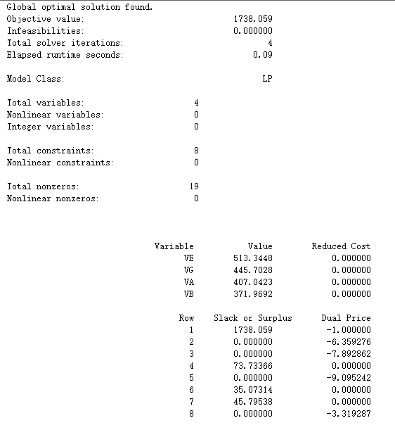

Conclusion:

If the machine is bad, replace it;

If the machine is excellent, good, or average, do not replace it.